**GOVERNMENT COLLEGE, BAHU (JHAJJAR)**

(*Affiliated to Maharshi Dayanand University, Rohtak, AISHE Code: C-50431*)

*Tel: 01259-279010 E-Mail - gcwbahu@gmail.com Website- gcbahu.ac.in*

**ICT – enabled facilities**

**Smart Class Room**

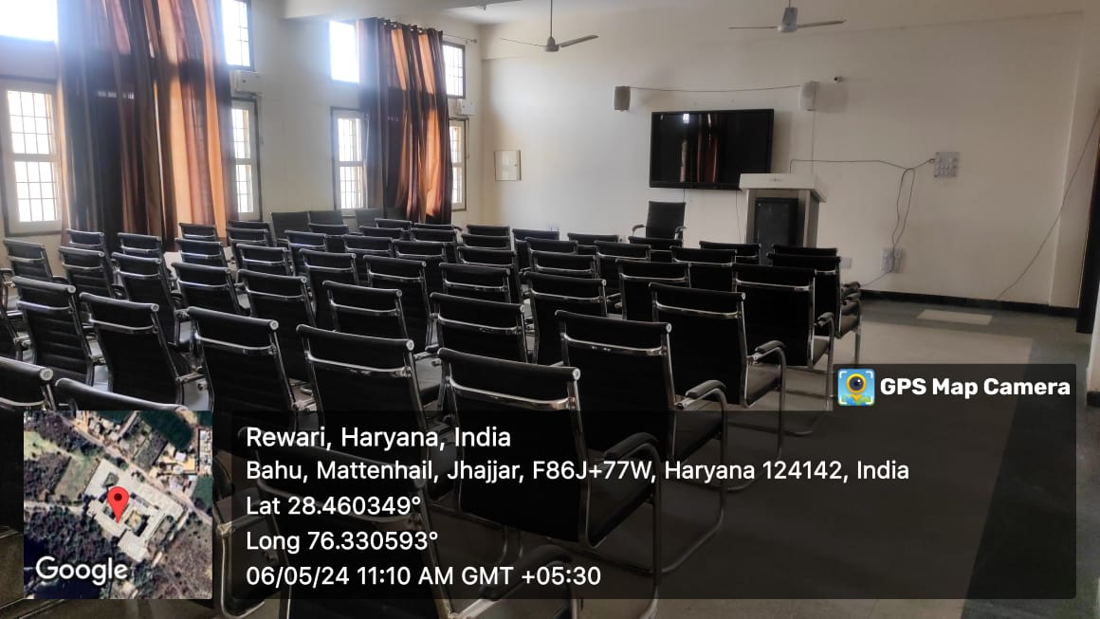

**English Language Lab**

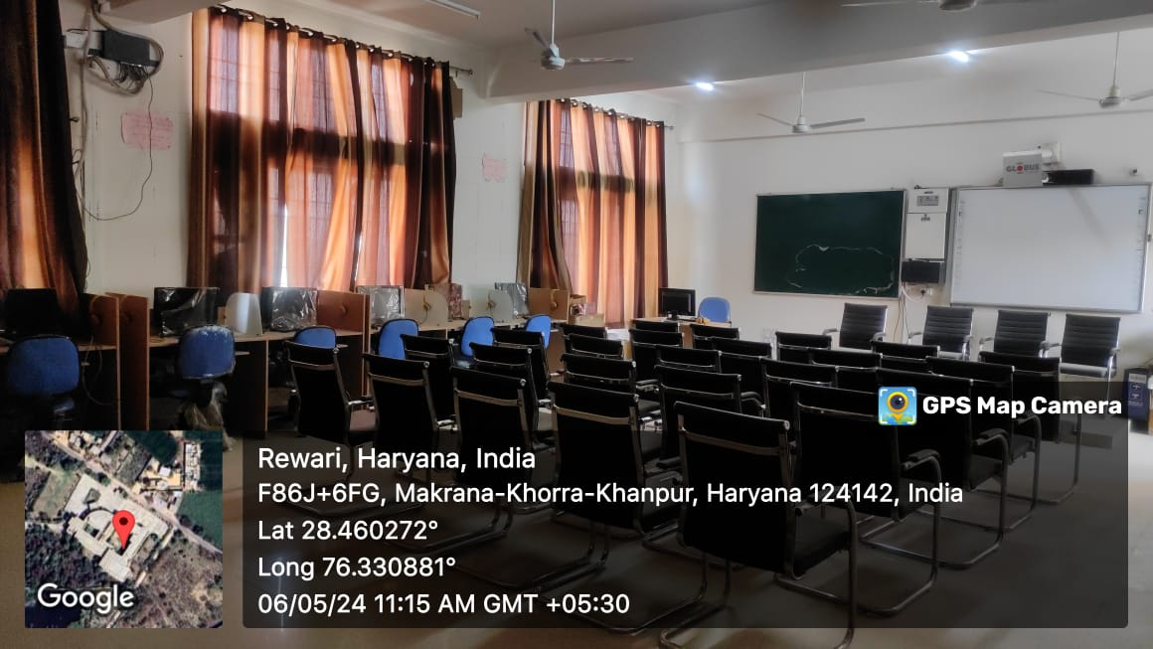

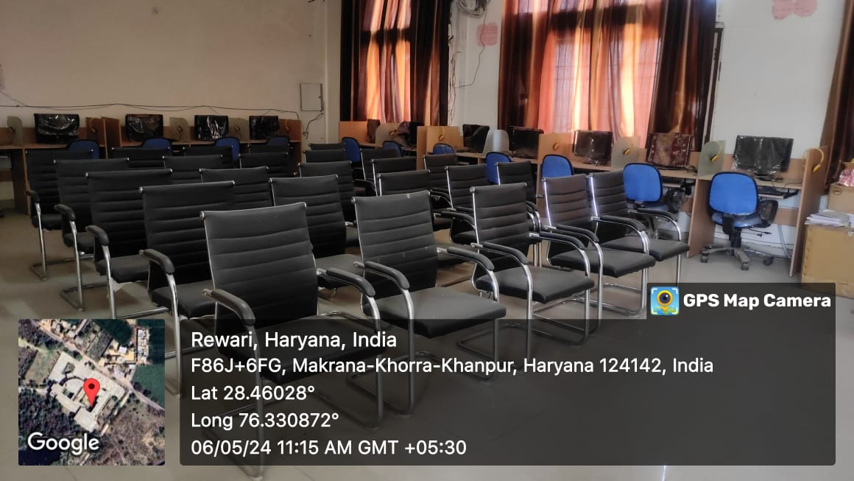

**Computer Lab**

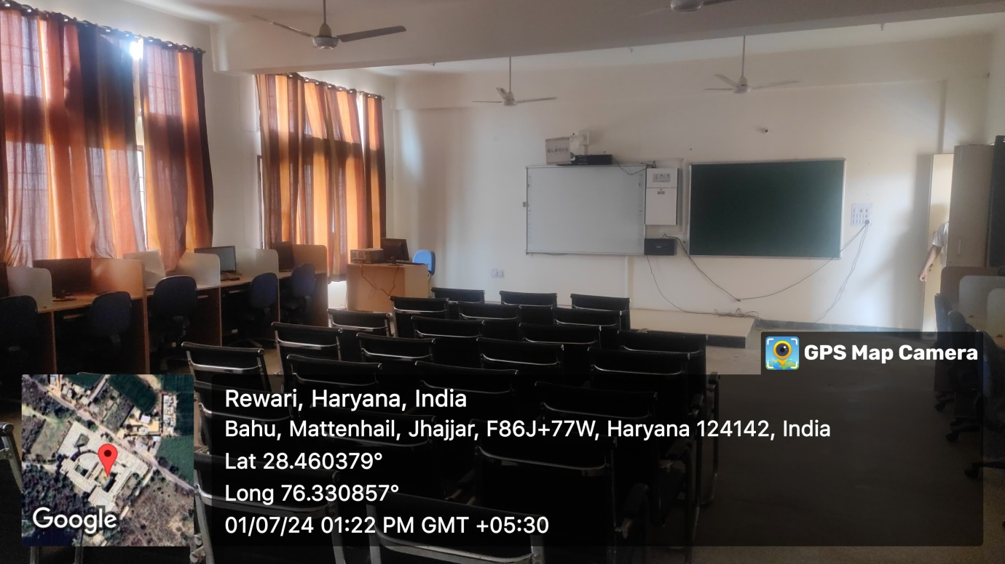

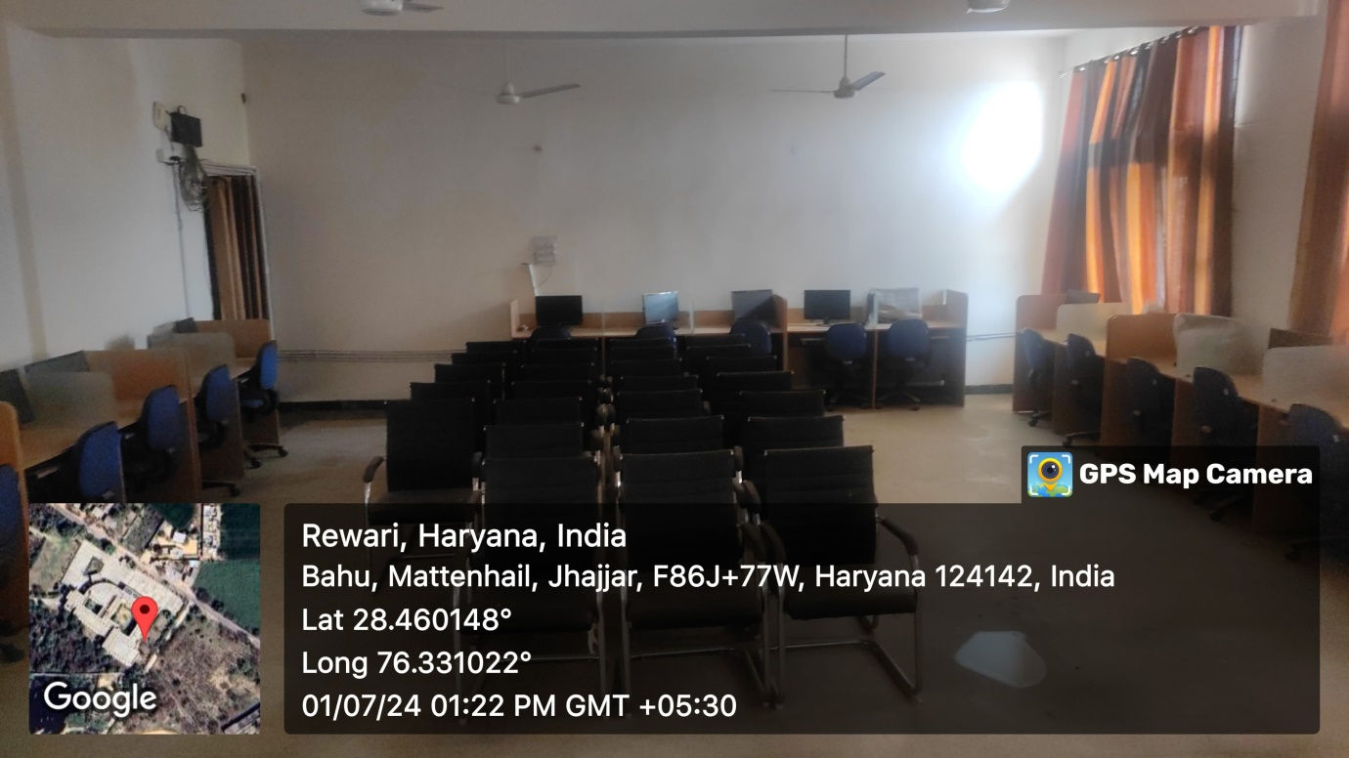

**Geography Smart Lab I**

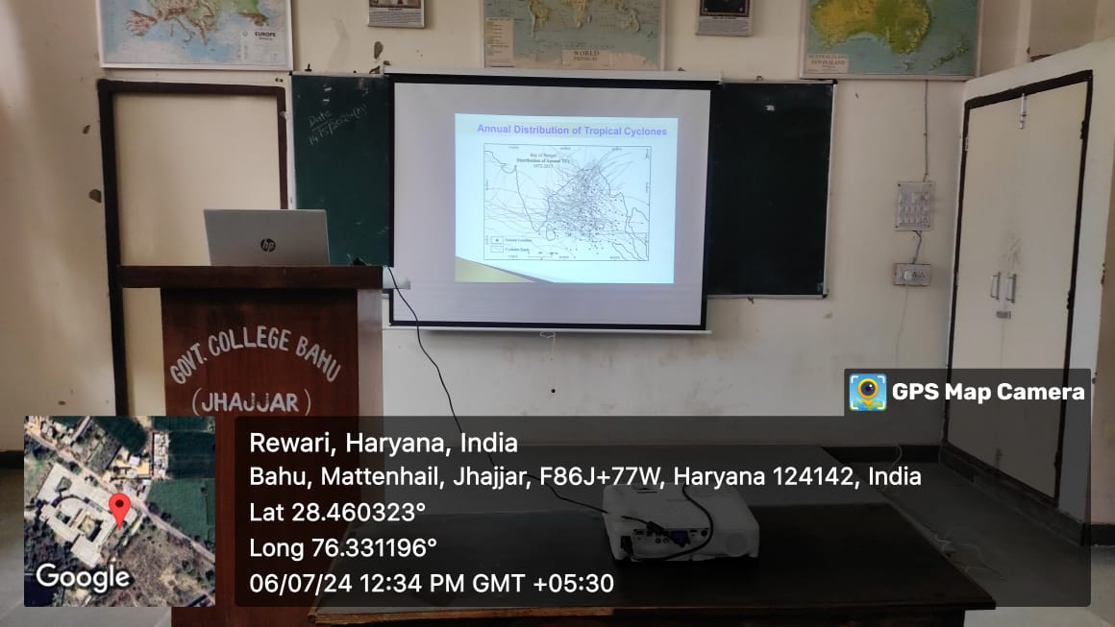

**Geography Smart Lab II**

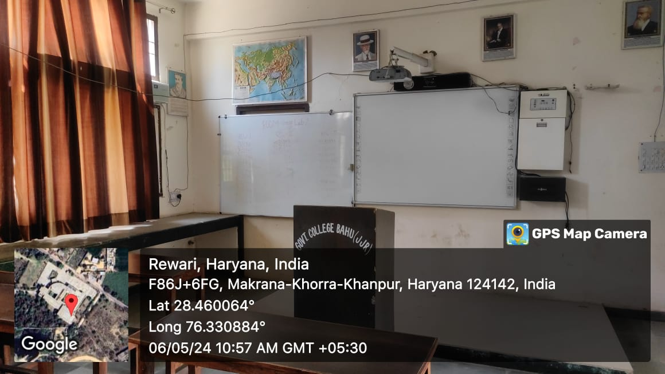

**Lecture Theatre**

